**COST MONITORING DASHBOARD**

Monitoring snowflake task credit consumption through Snowsight dashboards is crucial for effective cost management and resource optimization. Snowsight provides real-time visibility into the costs associated with running Tasks. This allows you to track cost trends, compare expenses across different dimensions, and identify cost-saving opportunities. Users can access the dashboards, interact with the data, and contribute to cost optimization efforts.

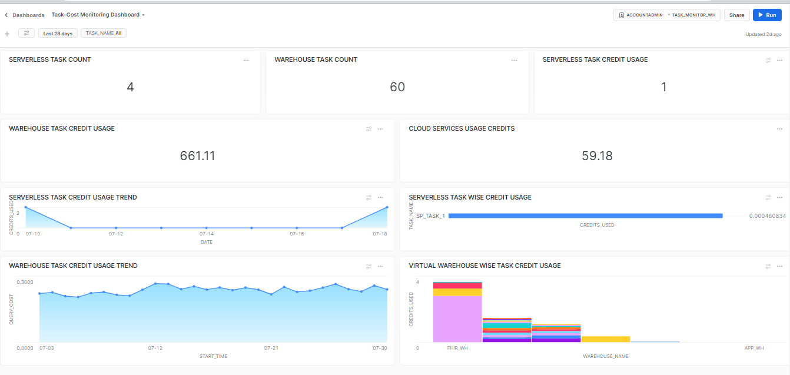

**FILTERS:**

* **DATERANGE(Default Filter)**
* **TASK_NAME(Custom Filter):**

Display Name :- TASK_NAME

SQL Keyword :- TASK_NAME

Role :- ACCOUNTADMIN

Warehouse :- TASK_MONITOR_WH

Options Via :- Query

Write Query :- select distinct name from snowflake.account_usage.task_history;

Go for the below selections :

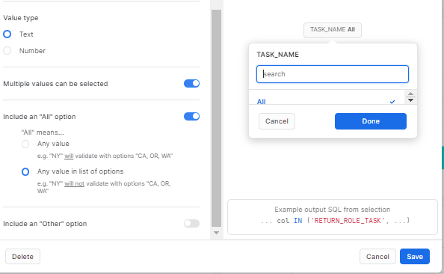

**2.1 SERVERLESS TASK COUNT :**

SELECT COUNT(DISTINCT TASK_NAME) FROM SNOWFLAKE.ACCOUNT_USAGE.SERVERLESS_TASK_HISTORY;

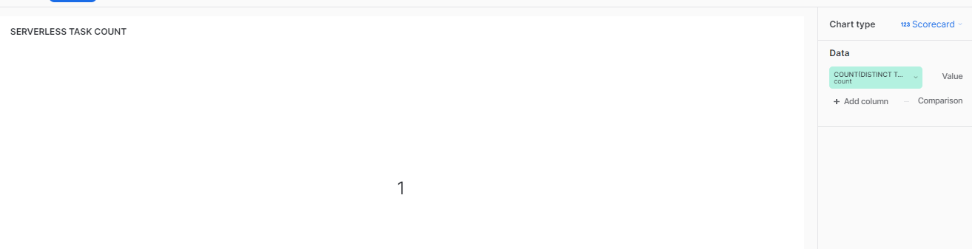

**2.2 WAREHOUSE TASK COUNT:**

SELECT COUNT(DISTINCT NAME) FROM SNOWFLAKE.ACCOUNT_USAGE.TASK_HISTORY

WHERE NAME NOT IN (SELECT DISTINCT TASK_NAME FROM SNOWFLAKE.ACCOUNT_USAGE.SERVERLESS_TASK_HISTORY);

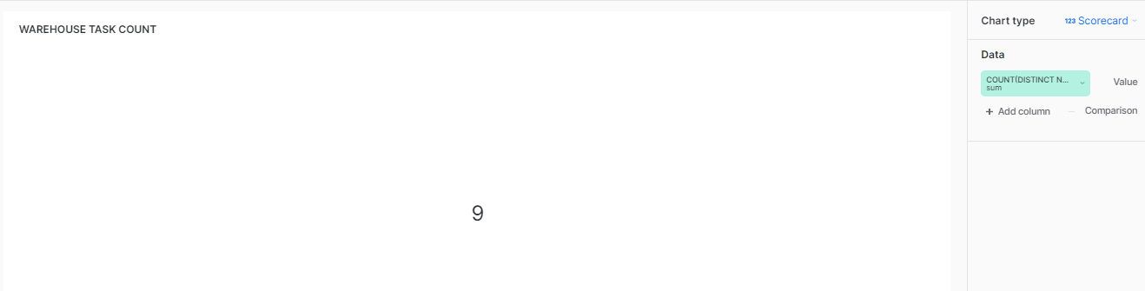

**2.3 SERVERLESS TASK CREDIT USAGE:**

select ROUND(100*sum(DAILY_CREDITS_USED),2) AS CREDITS_USED from (select

task_name,

sum(credits_used) as DAILY_CREDITS_USED

from "SNOWFLAKE"."ACCOUNT_USAGE"."SERVERLESS_TASK_HISTORY"

where start_time =:daterange

group by 1

order by 1 desc,2);

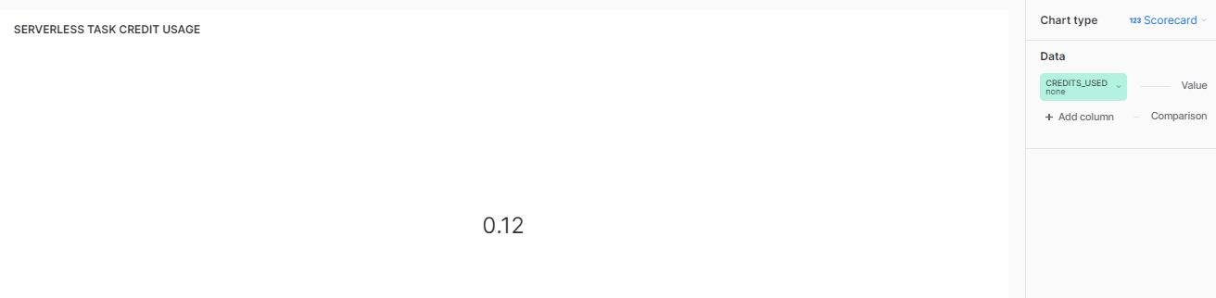

**2.4 WAREHOUSE TASK CREDIT USAGE:**

WITH

warehouse_sizes AS (

SELECT 'X-Small' AS warehouse_size, 1 AS credits_per_hour UNION ALL

SELECT 'Small' AS warehouse_size, 2 AS credits_per_hour UNION ALL

SELECT 'Medium' AS warehouse_size, 4 AS credits_per_hour UNION ALL

SELECT 'Large' AS warehouse_size, 8 AS credits_per_hour UNION ALL

SELECT 'X-Large' AS warehouse_size, 16 AS credits_per_hour UNION ALL

SELECT '2X-Large' AS warehouse_size, 32 AS credits_per_hour UNION ALL

SELECT '3X-Large' AS warehouse_size, 64 AS credits_per_hour UNION ALL

SELECT '4X-Large' AS warehouse_size, 128 AS credits_per_hour

)

SELECT

qh.TASK_NAME,

qh.STATUS,

qh.query_id,

ROUND(100*(qh.execution_time/(1000*60*60)*wh.credits_per_hour),2) AS query_cost,

qh.query_text,

qh.start_time

FROM TASK_MONITOR_DB.TASK_MONITOR_SCHEMA.QUERY_CREDITS AS qh

INNER JOIN warehouse_sizes AS wh

ON qh.warehouse_size=wh.warehouse_size

WHERE

start_time =:daterange;

//GROUP BY SUM(qh.execution_time/(1000*60*60)*wh.credits_per_hour);

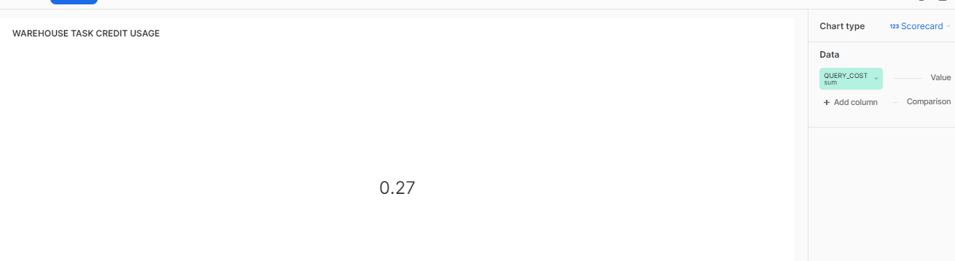

**2.5 CLOUD SERVICES USAGE CREDITS:**

SELECT ROUND(100*SUM(CREDITS_USED_CLOUD_SERVICES),2) AS CREDITS_USED_CLOUD_SERVICES FROM TASK_MONITOR_DB.TASK_MONITOR_SCHEMA.QUERY_CREDITS;

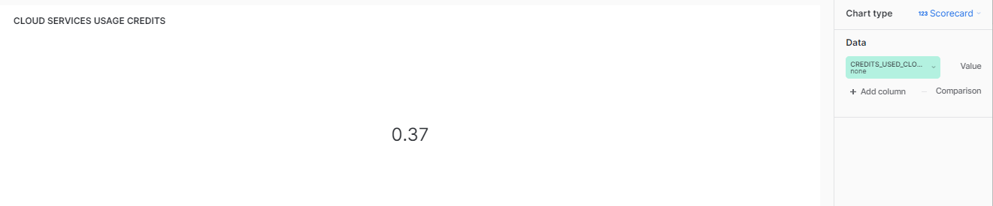

**2.6 SERVERLESS TASK CREDIT USAGE TREND:**

select COUNT(TASK_NAME) AS TASK_RUNS,CREDITS_USED,START_TIME AS DATE from "SNOWFLAKE"."ACCOUNT_USAGE"."SERVERLESS_TASK_HISTORY"

where start_time=:daterange

GROUP BY start_time ,CREDITS_USED;

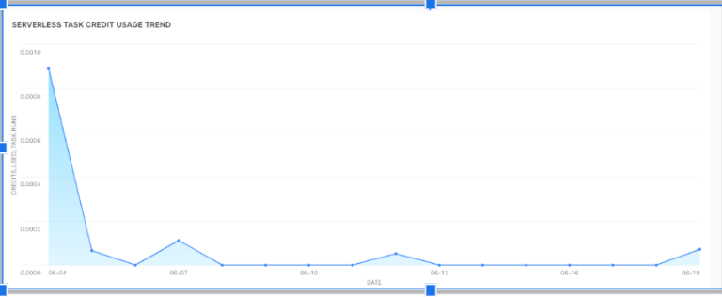

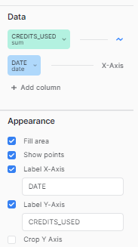

**2.7 SERVERLESS TASK WISE CREDIT USAGE:**

select TASK_NAME,CREDITS_USED,START_TIME,END_TIME,DATABASE_NAME,SCHEMA_NAME from "SNOWFLAKE"."ACCOUNT_USAGE"."SERVERLESS_TASK_HISTORY"

where start_time=:daterange AND TASK_NAME=:TASK_NAME;

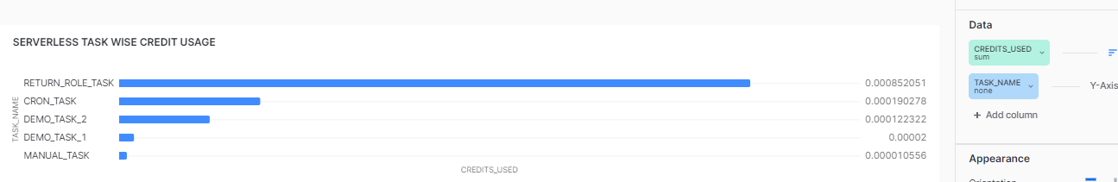

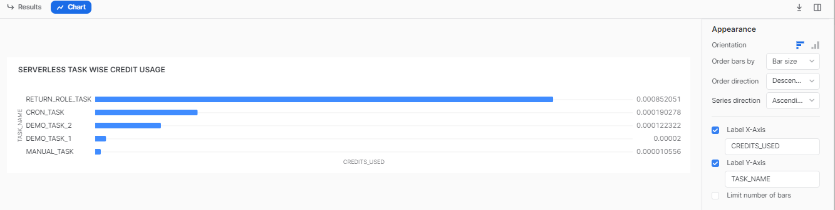

**2.8 WAREHOUSE TASK CREDIT USAGE TREND:**

WITH

warehouse_sizes AS (

SELECT 'X-Small' AS warehouse_size, 1 AS credits_per_hour UNION ALL

SELECT 'Small' AS warehouse_size, 2 AS credits_per_hour UNION ALL

SELECT 'Medium' AS warehouse_size, 4 AS credits_per_hour UNION ALL

SELECT 'Large' AS warehouse_size, 8 AS credits_per_hour UNION ALL

SELECT 'X-Large' AS warehouse_size, 16 AS credits_per_hour UNION ALL

SELECT '2X-Large' AS warehouse_size, 32 AS credits_per_hour UNION ALL

SELECT '3X-Large' AS warehouse_size, 64 AS credits_per_hour UNION ALL

SELECT '4X-Large' AS warehouse_size, 128 AS credits_per_hour

)

SELECT

qh.TASK_NAME,

qh.STATUS,

qh.query_id,

qh.execution_time/(1000*60*60)*wh.credits_per_hour AS query_cost,

qh.query_text,

qh.start_time

FROM TASK_MONITOR_DB.TASK_MONITOR_SCHEMA.QUERY_CREDITS AS qh

INNER JOIN warehouse_sizes AS wh

ON qh.warehouse_size=wh.warehouse_size

WHERE

start_time =:daterange;

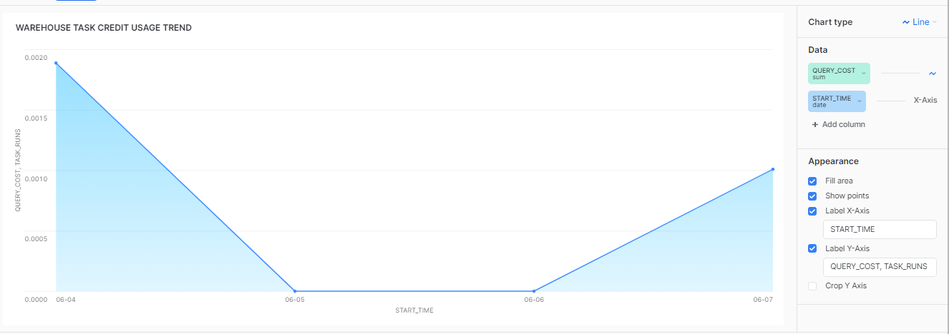

**2.9 VIRTUAL WAREHOUSE WISE TASK CREDIT USAGE:**

WITH

warehouse_sizes AS (

SELECT 'X-Small' AS warehouse_size, 1 AS credits_per_hour UNION ALL

SELECT 'Small' AS warehouse_size, 2 AS credits_per_hour UNION ALL

SELECT 'Medium' AS warehouse_size, 4 AS credits_per_hour UNION ALL

SELECT 'Large' AS warehouse_size, 8 AS credits_per_hour UNION ALL

SELECT 'X-Large' AS warehouse_size, 16 AS credits_per_hour UNION ALL

SELECT '2X-Large' AS warehouse_size, 32 AS credits_per_hour UNION ALL

SELECT '3X-Large' AS warehouse_size, 64 AS credits_per_hour UNION ALL

SELECT '4X-Large' AS warehouse_size, 128 AS credits_per_hour

)

SELECT

qh.TASK_NAME,

qh.execution_time/(1000*60*60)*wh.credits_per_hour AS Credits_Used,

qh.start_time,

qh.warehouse_name,

qh.warehouse_size

FROM TASK_MONITOR_DB.TASK_MONITOR_SCHEMA.QUERY_CREDITS AS qh

INNER JOIN warehouse_sizes AS wh

ON qh.warehouse_size=wh.warehouse_size

WHERE

start_time =:daterange AND TASK_NAME=:TASK_NAME;

